Corporate Performance Report

KPI commentary

2022/23 Quarter 3

Introduction

This Quarter 3 2022/23 (Q3) report is based on the latest available data, with Cabinet meeting dates necessitating the use of data extracted earlier than normal. Each Key Performance Indicator (KPI) states the time range of the data in the 'as of date' column in the Corporate Performance Dashboard and in the tables throughout the report.

The report provides information about the issues, causes and actions for the Key Performance Indicators (KPIs) and is presented in four sections aligned with the priorities of the council:
- Delivering better services
- Protecting the environment
- Supporting economic growth
- Caring for the vulnerable

Throughout the report the rating (RAG status) for each KPI is shown within the tables as:
Achieving the target/expected level of performance

Slightly below desired level

Requires improvement

The Corporate Performance Dashboard includes further information for each KPI, including:

- Latest performance summary
- Trend over time
- Detailed commentary on performance
- Definition
- Target and RAG thresholds
- Data sources

Instructions on using the Corporate Performance Dashboard are Here
.

Delivering Better Services
This section reports on performance relating to the efficiency of our services in key areas and the council's use of resources.
Link to the Corporate Performance Dashboard: Delivering Better Services Overview

Percentage of parents receiving their preferred school places

Note: No change to performance data this quarter.
The closing date for secondary school applications was 31 October 2022 and the primary closing date was 15 January 2023. The allocation of places will take place in the Spring Term 2023. Updated information against these indicators will be published in June 2023.

Take up of free funded Early Years education

Issues:
- Significant improvements have been made in the take up of free funded education as the action plan reported in the Q2 Corporate Performance Report is underway.
- Challenges around the take up of places for 2 year olds still remain in Pendle, Hynburn, Rossendale and Preston.
- Whilst we have also seen an increase in the take up of free funded educational places by vulnerable children linked to children's social care, further improvements are needed for these groups of children.

Actions:
- Our key strategy is to ensure all internal and external partners working directly with families have a good awareness and understanding of the funded entitlements so that they can proactively support families to take up the offer.
- Working closely with voluntary children's organisations to help raise awareness and promote messages to families.
- Close working with the Department of Work and Pensions and training of work coaches so that they can target families on universal credit.
- Close working with Ethnic Minority Achievement Team to break down barriers to access within Black and Minority Ethnic communities.
- Training for carers of looked after and previously looked after children to ensure they understand the importance of taking up the funded entitlements.
- Close working with social care and children & family wellbeing service to ensure families open to case workers are proactively supported to take up the funded entitlements.

Use of Libraries

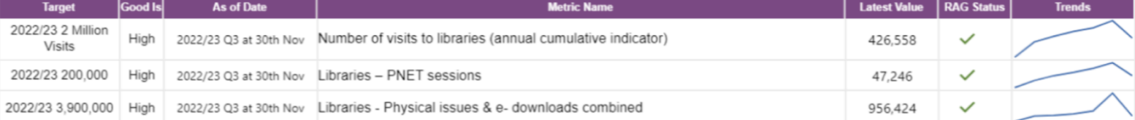
Issues/causes:
- Visitor figures have continued to recover steadily after reaching approximately two thirds of pre-pandemic levels by the end of 2021/22. As of 30 November 2022, the number of visits (426,558) compares favourably to the same period last year (306,7736), showing that despite seasonal factors we are still on track towards reaching this year's targets.
- The Christmas holiday period normally sees a significant fall in physical library attendance and building closures due to heating issues means lower overall figures are expected to be reflected in the final Q3 report.
- Public Network (PNET) sessions remain at lower levels than pre-pandemic but are increasing slowly. Traditional PNET Sessions usage saw an increase over the same period last year from 33,960 to 47,246. But in the longer term, service improvements made last year including free Wi-Fi at all sites, improved broadband and Wi-Fi printing will be factored into the performance data with targets being revised accordingly.
- Combined physical and electronic loans for the period compare well at 956,424 to the same October/November period last year which were 663,918.

Actions:
- We have recently announced our “warm and welcome” spaces scheme where people can visit libraries to get a warm drink, a space to sit, free computers and Wi-Fi, charging points for digital equipment, events and activities and help from staff to find further information about the support available during the cold weather.
- E-resources continue to be promoted and formats such as eNewspapers and eMagazines use has grown significantly, forming a more significant proportion of overall library issues.

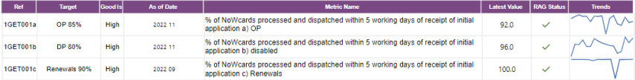
NoWcards Processing

All KPIs are performing well and on target, although it is not possible at present to report on new applications and renewals separately due to a change of IT system, which is under review by the system provider.
- Since moving to the new system in mid-September 40% of applications have been made online which reduces costs and improves communications.

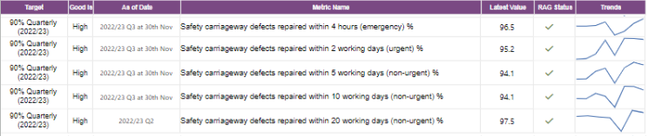
Safety carriageway defects

- Performance across all categories in the Safety Defect KPIs has been strong during Q3 up to 30th November and of particular note is the improvement in the emergency carriageway repairs.
- The work undertaken to review and improve the repair process, focusing on cost and time savings has helped to maintain and improve overall performance, even with defect numbers rising during Q3.
- There is concern however that the recent spell of extremely cold weather followed by rain will result in a steep increase in numbers during Q4.
- It is not possible to update the KPI on safety defects repair within 20 working days due to the timelines for this report.

Lighting (lamp out) faults

- The performance against the non-traffic management light repairs KPI continues to be excellent with again 100% of repairs being completed on time. Q3 is generally a period where more reports are received, due to the darker nights, but the team have worked extremely effectively to ensure there is no drop in performance.
- There is currently no update available for 20 days lamp out faults repairs due to the timelines for this report.
Highway's safety inspections

Note: No change to performance data due to timelines for this report.

Children with special educational needs/disabilities transported to school
- Performance is on target as of 30th Nov, with staff demonstrating flexibility and working well. The number of single passenger trips reflects a significant increase in the number SEND / College students travelling. Teams are optimising existing contracts wherever possible to mitigate the increase in numbers. However, the pressure of the increased passenger numbers is being felt across the team.

Customer access service
- The percentage of calls answered is now on target. This is due to significantly improved automated resolution following the review of several services delivered through Customer Access.
- Performance is likely to decrease in December due to the launch of Oracle Fusion and the Adult Social Care Telecare review, as both projects generated increased volumes of contacts for Customer Access.
- However, with more service reviews due in quarter 4 there is still confidence that the target of 88.75% could be met for the financial year.
- Customer satisfaction has decreased slightly in Q3 but remains above the target of 90%.
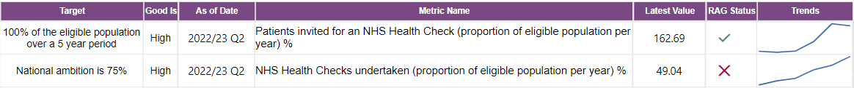
NHS Health Checks
Note: No change to performance data due to timelines for this report.
Update on the Actions:
- The Q2 corporate performance report included information about a training programme being developed for all providers delivering NHS health checks. Three of the virtual training sessions for providers have been delivered to date, providing training to 49 people across 29 practices.

Tobacco control
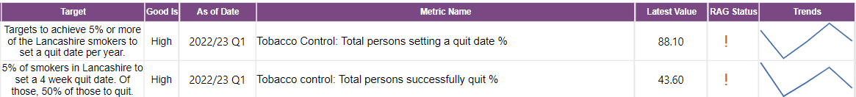

Note: No change to performance data due to timelines for this report.
Health visiting service
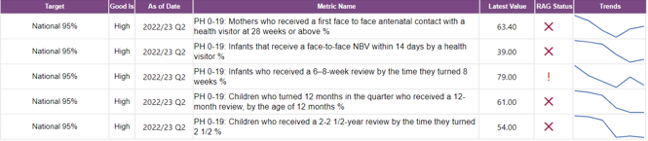
Note: No change to performance data due to timelines for this report.

Sexual health services
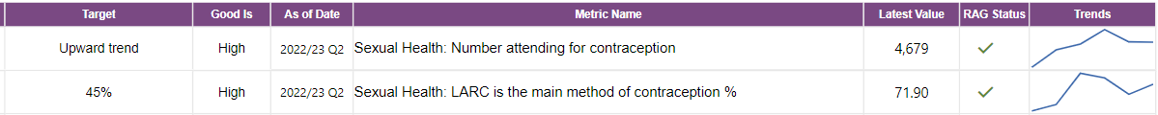

Although there continues to be minor quarter to quarter variations, the variations lie within normal range, and the service is generally performing well with both KPIs on target.

Health and Safety in Lancashire's schools.
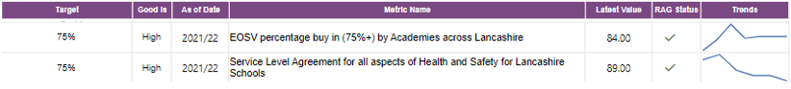
*EOSV = Educational off site visits
Note: No change to performance data for Q3.

Trading standards and scientific services
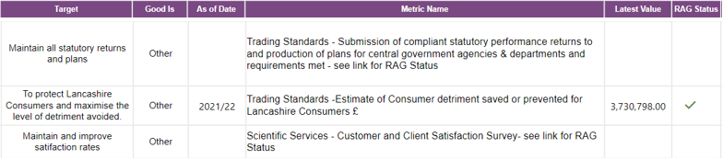
Note: No change to performance data for Q3.
Sickness absence in Lancashire County Council
Absence reporting is currently impacted by the implementation of Oracle Fusion. Reporting is being developed within Oracle Fusion which will enable further insights and analysis. An updated position for October is provided below, full quarter 3 data will be provided once reporting has been implemented.
October 2022 is in a better position than October 2021 with around 10% (1127) fewer absence days comparing the two months. 86% of staff had no absence in October 2022 compared with 87% in 2021.
We have observed a reduction to Long-Term absence, primarily Mental Health related absence but a slight increase to Short-Term absence, primarily around Colds, Flu & Infections which accounts for the slight increase to the number of staff absent.
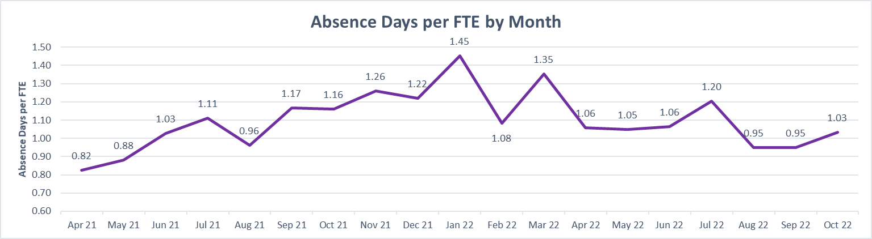
As shown in the above graph the current monthly trend is up from September 22, however this was expected due to seasonal sickness absence patterns and a low September position. Although we have had an increase between these two months, this period (September and October) is still performing better compared to 2021 with around 3000 less absence days which is a reduction of 13%.

Update to actions detailed in Q2 report:
Long term sickness absence is subject to regular review. Comparing to October last year there were 22% less Long-Term Sickness absence days per FTE. There are many Long-Term cases that HR Business Partners are working with services to close.

Budget Monitoring

The 2022/23 revenue monitoring position as at Quarter 3 is a forecast overspend of £2.5m, which by way of context is 0.27% of the county council's net budget. The overspend is due to a combination of variances across services including Education and Children's Social Care due to increasing prices for care and the anticipated pay award, and other minor overspend variations within the Resources Directorate. The overspend position is predominantly offset by increased levels of income across Adult Services, the largest elements being one-off. The forecast at Quarter 3 has seen an improvement due to an increased application of grant income across Adult Services and also as a result of additional income across the Highways service, with smaller changes to variances across other services such as Children's Social Care and Waste Management.

Protecting the Environment

This section reports on the work being undertaken to protect our environment, both by providing services to Lancashire's citizens and by improving the environment footprint of the council's services.

Link to the Corporate Performance Dashboard: Protecting the Environment Overview

Waste management

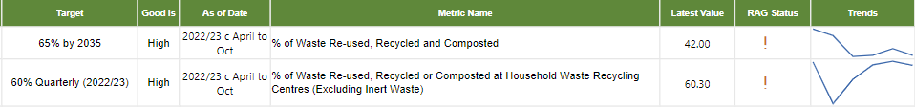
Issues
- The amount of recycling collected in the first seven months of this year is down by 3,500 tonnes compared to the same period in 2021/22. Doorstep collected residual waste dropped by 6,500 tonnes over this period. This is in the context of total annual arisings of circa 103,000 tonnes of collected recycling and circa 313,000 tonnes of collected residual waste.
Causes
- Generally, waste arisings went up during the pandemic and have since been falling, and staff being unable to engage with the public or handle waste items during the pandemic reduced performance at Household Waste Recycling Centres (HWRC).
- The final HWRC cumulative recycling rate for Q1 and Q2 was 60.6%.
- The KPI is currently rated as amber due to the impact of seasonal variation in volumes. However, currently all HWRCs are showing improved performance compared to 2021/22.
Actions
- In the last quarter the Waste service has procured a new contract for the transportation of waste materials in Lancashire (HWRCs) and the provision of services for the acceptance and composting of green waste arising in East Lancashire although the latter is subject to award.
- A change to the management structure on all HWRCs is being put in place which is expected to further improve recycling performance and increase customer engagement.

Lancashire County Council's vehicle fleet

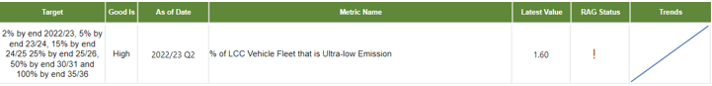
Note: No change to performance data for Q3.
Supporting Economic Growth

This section reports on the council's activities to support new businesses, including the development of infrastructure and, recognising the importance of knowledge and skills development, educational attainment.

Link to the Corporate Performance Dashboard: Supporting Economic Growth

Educational attainment

General issues:
- Lancashire experienced a high impact from the COVID-19 pandemic, with school absence rates being higher than the national averages. During 2020/21, there were 72 full closures of primary schools. Research shows that absence rates impact on educational attainment.
- OFSTED outcomes from post-pandemic inspections, have continued to be Good, highlighting the work that schools and early years education providers have done to provide high quality education and stability for children during such an unprecedented time.
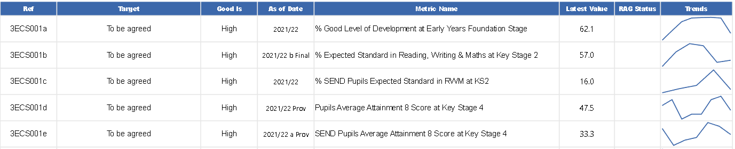

Early Years Foundation Stage (EYFS)
Issues:
- Following two years of cancellations of assessment profiles at the end of the EYFS during 2019/20 and 2020/21, data has been collected for 2021/22.
- 62.1% of Children assessed at Early Years Foundation Stage achieved a 'Good Level Development' this is around 3% lower than the national average of 65.2% but higher than Regional (61.7%). This cannot be compared to previous years' data as the Early Learning Goals have changed under the EYFS reforms.
- We are positioned in the 4th quartile nationally against this indicator (ranked 122 from 152 authorities).
- The attainment gap between genders remains with girls (69.1%) outperforming boys (55.8%).

Actions:
- Provision of a large range of Continuous Professional Development opportunities for reception class practitioners.
- Consultants working with schools over a period to improve outcomes.
- The Early Years Quality Improvement Team work in localities to provide support to clusters of schools each term.
- Providing support for schools in difficulty.
- Delivering a range of programmes, including several which focus on improving attainment by boys.
- Significant support has been provided to every primary school for communication and language development in order to close the word gap (which is where some children are thought to have heard significantly more words than their peers, when starting school).

Key Stage 2 (years 3 to 6 in primary school)
Issues:
- Revised data has been published for 2021/22. The Lancashire pupils reaching the expected standard in reading, writing and maths at KS2 improved to 57% compared to the provisional figure of 56% reported in the last quarter. Rates however remain below the latest National (59%) and Regional (58%) and the 2018/19 academic year (64%) performance.
- Lancashire is ranked 101 of 150 authorities for the percentage of pupils reaching the expected standard in reading, writing and maths at KS2.
- The attainment gap between genders remains, with girls (61%) outperforming boys (53%).
- The Special Educational Needs Support pupils reaching the expected standard in reading, writing and maths at KS2 was 16%, a reduction compared to the 2018/19 performance (20%). Rates remain below the National (21%) and Regional (20%) performance. Lancashire is ranked 133 of 150 authorities.

Actions:
- Provision of a large range of courses/support sessions to schools covering all aspects of Key Stage 2 Attainment and Progress.
- Consultants working with schools over a period to improve outcomes.
- Lancashire Professional Development Service works with clusters of schools.
- Reviewing our offer and ensure we are offering training in those areas of locality that most need it.
- Providing support for schools in difficulty.
- Delivering Education Endowment Foundation work focused on children in the East of Lancashire where data shows highest need.
- Delivering a range of programmes, including several which focus on improving attainment by boys.
- Systems are being developed to share practice that has proved to be effective in Lancashire schools as well as approaches to support collaborative problem-solving and inter-school support for pupils with SEN. This is also a key part of the Education Strategy focusing on outcomes of vulnerable pupils and therefore will be part of this action plan moving forward.

Key Stage 4 (years 10 and 11/GCSE)
Finalised Key Stage 4 data will be published during February 2023

The actions reported in the Q2 Corporate Performance Report are ongoing, and in addition we are building better relationships with our secondary schools who don't buy into the traded offer so we can have a greater understanding of education as a whole in Lancashire and can intervene where necessary earlier.

16/17-year-olds and care leavers in Employment Education or Training (EET).

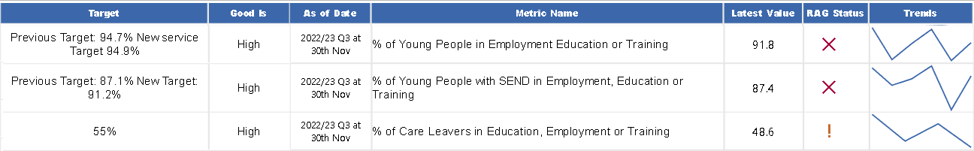
Issues:
16/17 year olds
- Whilst compared to November 2021, performance has improved for both measures, further work needs to be done to reduce the number of people whose current situation is not known across the overall cohort.
- For young people in employment, education or training, November 2022 performance was 91.8% (compared to 91.6% in November 2021) and for young people with SEND, performance was 87.4% (compared to 86.5% in November 2021).
- There are more young people in employment education or training overall in November compared to the same time last year, but the overall cohort has increased, masking this improvement.
Care leavers
- At the end of November 2022, 301 of the 625 (48%) care leavers aged 18-20 were in Employment, Education or Training (EET), which, reduced performance on the previous quarter (50.1%), on November 21 (50.7%), and remains below target.
Causes:
16/17 year olds
- There is an increase in the overall cohort size, with 815 more 16 and 17yr olds than last year, which in turn increased the workload.
- The service continues to face staffing and resources capacity for this area of work.
- We are seeing an increase in the number of young people leaving their post 16 education early and this is having an adverse impact on the number of people recorded as 'not known'.
Care leavers
- It is not usual to see a dip in EET figure at this time of year, which is likely to be attributed to a reduction in seasonal work, the cost-of-living crisis and industrial action.
Actions:
16/17 year olds
- A member of support staff has been appointed and this will create an additional resource in the new year.
- Youth workers within the Children and Family Wellbeing Service have started to contact young people within the NEET group to help them reengage but it is too early to see an impact at this point.
Care leavers
- We continue to work alongside the Employee Support Team and the Virtual School to create opportunities for our young people.
Supporting new businesses and business growth
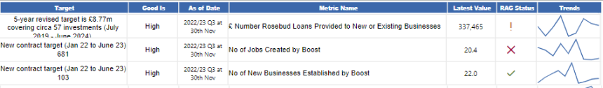

Rosebud Loans
Issues:
- Although this quarter has continued to be positive with a healthy number of investments coming to fruition these are less in value but reflective of the smaller businesses looking to kick on and grow through investment.
Actions:
- There is still time before this quarter completes and with a further £375,000 across 3 investments expecting to come to fruition being level on target.

Boost ERDF Support
Issues:
- Outputs are lower than anticipated, which is a reflection on the "business" and time poor realities that a lot of our businesses are facing.

Causes:
- Whilst we don’t have the headline numbers we expected, there is a strong pipeline of delivery and our remaining service providers are optimistic that they will be able to deliver to the headlines promised, the challenge is not so much in finding the businesses but more around their ability to commit to the 12-hour commitment to secure an intensive assist.

Actions:
- Notice of termination of two contracts has been issued following consistent underperformance. The management team are considering alternative delivery arrangements, and do not anticipate any fundamental changes in service offerings to the Lancashire Business community. This is being monitored closely within current project management arrangements.

Caring for the vulnerable
This section includes performance about our adult social care services, support to children, young people and their families, and public health.

Link to the Corporate Performance Dashboard: Caring for the Vulnerable Overview

Adult Social Care Services
This section is divided into 4 areas to reflect the Service Plan for adult social care services: shaping the market, making the right impact, promoting independence and choice, and financial sustainability.

Shaping the market
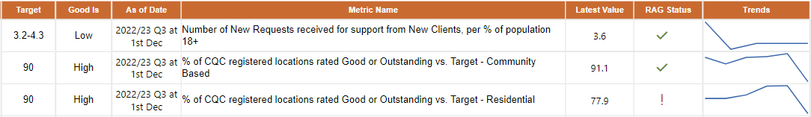

Number of New Requests for support from new clients per % population 18+
Issues:
- Requests for support from adult services are lower than that of comparator authorities, and this is based on the latest available comparator data from 2021/22. Although relatively fewer people contact us, we draw more people in for an assessment for formal care and then provide more formal support than others.
- There has been a slight decrease from the same period last year, and this is consistent with England and our comparator Local Authority averages.

Causes:

- Work is underway within the Living Better Lives Transformation programme (our strengths-based practice model which aims to further improve people’s independence) and a pilot in the east of the county to improve people’s access to community provision. This will reduce our reliance on formal packages of care which can then be used to further support timely discharge from hospital which is a particular pressure during the winter period.

Actions:
- We are further developing our understanding of our population needs through our Social Care reform work (which will continue for some aspects despite the government’s planned delay until 2025) and Living Better Lives in Lancashire programmes, which support us to better understand what people can do for themselves and in turn what their social care needs are.
- Our aim is to enhance and shape the market to enable people to find good quality, local support without needing to always contact the council directly. We have set a target range of between 3.2% of the adult population contacting the council for social care support (which was the performance of best performing local authority) and 4.3% (which was the England average).

Care Quality Commission - Residential home & Community Based Services
Issues:
- We are currently below the target (80.9% against 90%) in relation to residential care homes rated as good or outstanding by the Care Quality Commission (CQC). This performance varies across Lancashire and is different for nursing versus residential services. Residential Care is 82.3% good or outstanding whilst Nursing provision is 77% good or outstanding. Districts in the East of the county generally have more good to outstanding care homes than the West of the County.
- Community-based services are currently well above target (96.34% against 90%).

Causes:
- Our home care framework requires commissioned community providers to be rated as good or outstanding at the onset of issuing the contract, this is the main reason why performance in this area is strong.
- In the care home sector, we will commission places from providers with differing CQC ratings – outstanding, good or occasionally requires improvement – based on an individual's choice. We have a strategy to improve care home ratings by supporting them to make improvements. Analysis from the quality team has highlighted common themes in relation to financial issues, lack of leadership and workforce issues which have been more acute following the pandemic. We are working to support providers to make the improvements in these areas.
- A number of providers that were rated good prior to the pandemic are now being assessed as requires improvement because they are yet to fully recover from the pandemic.

Actions:
- With specific regard to residential homes, a recovery plan is in place to continue this support. However additional challenges are now facing the sector which include a significant loss of workforce and increased costs associated with the cost-of-living crisis. These are national issues. Some providers are making the difficult decision to exit the market.
- We are working with the NHS locally and nationally to support providers with the current challenges they face. This includes supporting providers with improvements and developing a longer-term plan ensuring that we only commission good quality care. For example, we have recently established a new Quality Team which will focus on improving quality and standards of care for both internal and external provider services.
Making the right impact

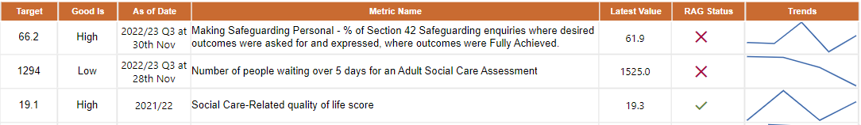

Making Safeguarding Personal - % of safeguarding enquiries where desired outcomes were asked for and expressed, where outcomes were fully achieved.
Issues:
- It is pleasing to report that Quarter 3 performance has improved as a consequence of improving recording practice.
- We remain 5% short of our target of 66.2%. This target is not set at 100% because we cannot always fully support or fully resolve what people are seeking.
Causes:
- The redesigned Safeguarding service is now fully operational and new ways of working ensures that making safeguarding personal (MSP) is at the heart of safeguarding practice and a single social worker approach means that the individual only has to tell their story once. Discussion takes place with the individual throughout the safeguarding review process about setting outcomes that are meaningful and achievable.
- Whilst we are confident that MSP is happening in practice there remains a data lag and the inputting of data needs to be more robust. This will improve over time as new working practices in the team bed in.
Actions:
- All managers have focused on working with their staff team to ensure that they understand the importance of and give utmost care to data input on our information technology system regarding MSP outcomes.
- Managers continue to support staff with practice but will also robustly audit records and analyse the data to ensure we are on a trajectory to achieve the target.
- A new safeguarding quality and performance manager has been appointed and will take up post from 1/1/2023 and will further support audit and quality improvement work including MSP performance improvement.

Number of People waiting over 5 days for an assessment
Issues:
- We initially prioritised those waiting more than 6 months and have had great success with this and are now prioritising those people waiting more than 3 months. As a consequence of this prioritisation, our reported 5 days target figure has moderately reduced from 1736 in Q2 2022/23 to 1525 Q3 2022/23. Although this demonstrates progress, further work is taking place to achieve the target.
- Of these total numbers of people waiting for an assessment roughly half are people who need to be re-assessed for reasons such as their needs have changed. We are developing our monitoring arrangements so that we can distinguish between people who are waiting for their first assessment and those who are waiting for a re-assessment.
- The number of people waiting less than 5 days is 195 and all the people who contact us for an assessment receive an initial triage.

Causes:
- More people are accepted for an assessment.
- Staffing capacity challenges have been experienced, particularly in services for older people and people with physical disabilities.

Actions:
- Targeted work continues to address the waiting lists for a social care assessment.
- Significant progress has been made around reducing the number of people waiting longer than 6 months for an assessment, the focus has now been moved to those waiting more than 3 months.
- Weekly reviews take place to closely monitor the performance. Teams are focussed on reducing the numbers as well as reducing the length of time people have to wait.
- Further work is underway to develop a measure which focuses on the timeliness of assessment completion, as this will be a complimentary indicator in terms of reporting on our overall responsiveness to people in need of support.
- Our timeline for achieving the target is end of the financial year 2022/23. This KPI measures waiting times for assessment and does not include those people who currently receive a service and who are overdue a review. Review work is also being prioritised and good progress is being made.
Adult Social Care Related Quality of Life survey
Note: there is no update to performance data for Q3
- This is an annual survey of people receiving services from adult social care in Lancashire. The next survey is being undertaken during Q4, and initial results will be available for the year-end report.

Proportion of people waiting 28 Days or more for a package of care
- We are considering the timeframe of this indicator so this will reflect the service experienced by our users. At this stage we have not set a target, but it is clear that 'good' will be low. We will look to provide data, with some historical trends, in the year-end report.

Promoting independence and choice
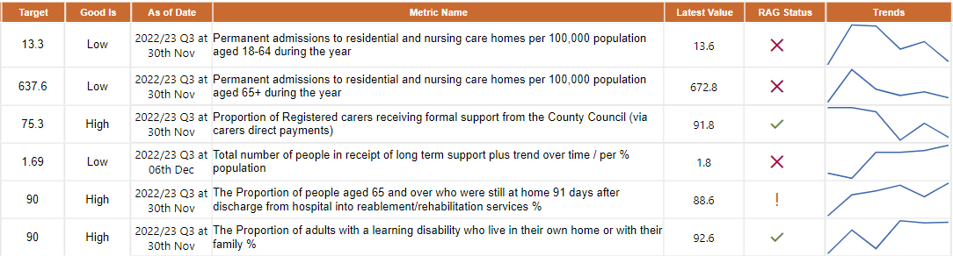

Permanent admissions to residential and nursing care homes per 100,000 population aged 18-64 and aged 65+ during the year
Issues:
Adults 65+
- We aim to continue our overall downward trend and have set a target of 637.6, which we consider to be realistic when considering the challenges we often face with sourcing non-residential care with cost-effective providers.
Causes:
- Specialist staff shortages and lack of non-residential care provision can result in there being little alternative to support a discharge from hospital than a residential placement.
- Winter pressures are causing strains on all services. Government have made additional short-term funding available to support discharges from hospital but due to the lack of community provision in some areas, some people are being admitted to residential provision (both short and longer term) in order to relieve the immediate pressures on hospital beds.
- Residential admissions slowed during the main part of pandemic but since then the rate of admissions has started to increase.
Adults 18-64
- In this age band there has been an improvement from 15.45 (Q2) to 13.6 in (Q3) which is very close to the agreed target.
- This is an early indication that the actions implemented have been effective.

Actions:
Several initiatives are in place with the intention of avoiding admissions and reducing the number of people in residential care across both age bands above. These include:
- Senior Management oversight at the Complex Case Forum, managers in mental health having more supportive discussions with health colleagues about long term support needs.
- Reviewing the care and support services that people receive to avoid a hospital admission and the services that people receive as part of their rehabilitation and recovery following a stay in hospital (referred to as intermediate care services).
- Working with District colleagues to identify and address housing issues that may be preventing timely discharge from hospital.
- Using a 'home first' approach to assess people at home following a hospital admission rather than assessing people whilst they are still on a hospital ward to provide a better understanding of what people can do for themselves and what their social care needs are.
- We are utilising the Adult Social Care Discharge Fund to provide a range of initiatives to support hospital discharge during this winter period.

Proportion of registered carers receiving formal support from the County Council
- We continue to maintain our high levels of performance for the proportion of carers receiving formal support from the County Council. Particularly worthy of note, is direct payments to carers have proved to be much more efficient and promote independence and choice.

Total number of people in receipt of long-term support per % of the population aged 18+
Issue:
- We provide more people with long term support (per head of population) than our nearest neighbour authorities.
Causes:
- People are being drawn into the formal care system who otherwise could have been supported by accessing universal and community services.
- Some people have waited too long for an assessment (particularly during the pandemic) and this means they developed more complex needs and therefore required formal support.

Action:
- The introduction of self-assessment and sign posting to community services and increasing our digital offer to promote self-reliance and independence.
- Backlogs have significantly reduced, and this will allow for earlier interventions and reduce long term needs. The backlog work is due to be completed in February 2023.
- The Living Better Lives in Lancashire Programme is gathering momentum and it is anticipated to support an improvement to our performance over time, as we progressively promote increased independence by better use of community support.

The proportion of people aged 65 and over who were still at home 91 days after discharge from hospital into reablement/rehabilitation services
Issue:
- We aim to continue our comparatively high performance and move closer to the 90% target. However, this will prove challenging, as we will be increasingly working with service users with more complex needs.
Actions:
- Continued close monitoring of service user outcomes.
- Significant work has been undertaken to improve the way in which people receive support to enable them to recover from a stay in hospital through our reablement service.
- A review of both the reablement service and the wider intermediate care provision continues to inform future operational delivery and the re-procurement of the service which is due by the end of 2022/23.

Proportion of adults with a learning disability who live in their own home or with their family
- We continue to be a top performer (when compared with our 'nearest neighbours').
Actions:
- The work being undertaken to deliver on the ‘Housing with Care and Support’ Strategy 2018-25 has strengthen our approach to working with providers, developers, and partners. This includes working closely with the district councils.
Financial sustainability

Long term support average cost per person per week
Issues:
- We are seeing an increase in the number of homecare packages sourced off framework due to capacity issues of providers on the current framework, this drives higher costs.
- Continued pressures within the NHS, particularly discharge arrangements, are driving up the average costs. This is as a consequence of the NHS directly procuring care at a higher cost. This is one of the issues we are working closely with our NHS colleagues to address, and we are developing a pilot approach to joint commissioning with a number of providers.
- Furthermore, we are seeing increased costs in Supported Living, specifically in relation to traditional supported living settings. This is driving the transformation programme to move to a more apartment accommodation model as traditional models' costs continue to increase.
Actions
- The Homecare Tender due to go out for procurement in April 2023 will address the issues relating to the current homecare framework.
- Continued implementation of the supported living modernisation programme to replace traditional housing stock with alternative apartment type accommodation. We are expecting that some traditional accommodation will be decommissioned in the near future.

Children and families

Children and Families Wellbeing Service.

Issue:
- Data for October and November suggests the percentage of children and young people who received targeted early help support which met their identified needs improved significantly and is above target.
Causes:
- The service have been focusing on obtaining and maintaining engagement and analysing local data at local level to identify and set actions for those districts with poorer performance.

Actions:
- Continue to build on improvements made through the planned workshops and engagement tools.

Looked after children
Percentage of children looked after who are actually living in Lancashire
Issue:
- With 1,544 looked after children now living in Lancashire, the proportion (80.2%) has improved further and is now above target.

Causes:
- New commissioning arrangements focusing on local placements commenced in May 2022 and August 2022.
- A replacement provider to our children's home block contract was appointed in May 2022 which increased the number of local placements. This is now starting to show impact.
- The Children in our Care service has focussed heavily on ensuring the stability process is well embedded to support with managing vulnerable homes and they have sufficient notice periods to enable placement finding as a contingency where appropriate.

Actions:
- Continue testing the effectiveness of our commissioning work.
- Building on our consistent application of the stability process to maintain homes for our children locally.
- Continued work of the Where Our Children Live project –opening of additional inhouse residential homes in Lancashire.

Children becoming looked after
Issue:
- With 85 children becoming looked after during October and November 2022, the rate remains low at 3.4 per 10k. This is below the national and North West region rates which is in line with expectations given our emphasis on preventative approaches including Family Safeguarding. It is difficult to predict a December figure due to the volatile nature of this indicator. Therefore the rate for quarter three is a total for two months and is not comparable to previous quarters.

Causes:
- Family Safeguarding is set up to ensure that more children stay with their families where it is safe to do so.

Actions:
- The service is reviewing recruitment and retention and workload in Family Safeguarding in order to ensure that we have fidelity to the model, we believe that stronger fidelity will result in fewer children entering care.
- The service are also developing our 'edge of care' services to prevent older teenagers in particular entering care

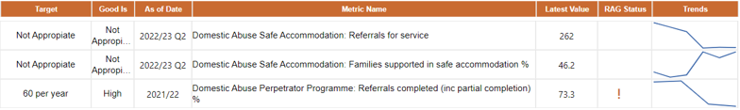
Domestic abuse

Note: there is no update to performance data for Q3

Adult Perpetrator programme

Update on planned actions from Q2:
- To achieve our local target, a recovery plan is now in place with the service provider to increase referrals from other partners by raising awareness with a variety of statutory and voluntary organisations, including those engaged with the emerging Multi-Agency Risk Reduction Assessment Coordination approach to domestic abuse. The recovery programme is already improving referrals into the service.

Substance misuse and alcohol
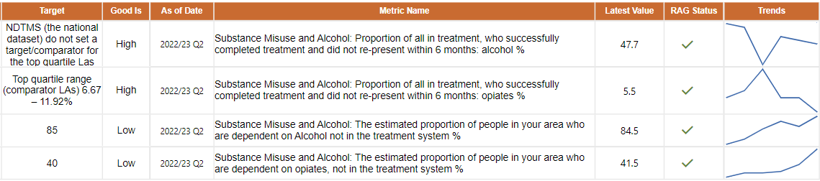

Although the KPIs for this service are on or above target, the following issues are being monitored and actively actioned as they impact both the number of people in treatment and treatment outcomes.
Issue:
- Limited capacity in the treatment system coupled with a need to increase referrals from partners.
Causes:
- Increased complexity and poorer general health of people coming into treatment having an adverse impact on outcomes and capacity.
- Impacts from the Covid pandemic causing reduced capacity.

Actions:
- The Office for Health Improvement and Disparities (OHID) have allocated additional investment for Lancashire through the Supplemental Substance Misuse Treatment and Recovery Grant. In 2022/23 this amounts to £2,584,279.
- This will allow us to increase the quality of key working and case management, target individuals in underrepresented groups, and improve engagement with partners.
- The terms of the grant state that we must improve the treatment outcomes and increase the number of people in treatment by 20% (based on 2021/22 data) by 2025, phased over three years. In year one we need to draw in an additional 192 people into the treatment system.

